EXP 02
Write JavaScript Programme to validate the following fields of the HTML Registration page.

AIM:
To write JavaScript code to validate user input in a registration form. The validation will ensure that the data entered by the user meets specific criteria for each field. This will help in maintaining data integrity and prevent invalid submissions.

ALGORITHM:
1. Input:
- The user fills in the following fields: First Name, Password, E-mail, Mobile Number, Last Name, and Address.
2. Validation Steps:
- Validate First Name:
  - Check if the first name contains only alphabets.
  - Ensure the length of the First Name is at least 6 characters.
  - If any of these conditions fail, display an error message indicating the required input.
- Validate Password:
  - Check if the password is at least 6 characters long.
  - If it is less than 6 characters, display an error message.
- Validate E-mail:
  - Use a regular expression to check if the email follows the standard pattern: name@domain.com.
  - Ensure that the email contains no invalid characters and matches the required pattern.
  - If it doesn't match, display an error message indicating an invalid email format.
- Validate Mobile Number:
  - Check if the mobile number contains exactly 10 digits.
  - Ensure there are no alphabets or special characters.
  - If the number is invalid, display an error message indicating the correct format.
- Validate Last Name:
  - Ensure the Last Name field is not empty.
  - If it is empty, display an error message.
- Validate Address:
  - Ensure the Address field is not empty.
  - If it is empty, display an error message.
Program:

index.html:
<!-- index.html -->
<!DOCTYPE html>
<html lang="en">
<head>
<meta charset="UTF-8">
<meta name="viewport" content="width=device-width, initial-scale=1.0">
<title>Student Information Management System - Registration</title>
<link rel="stylesheet" href="style.css">
<script src="script.js" defer></script>
</head>

<body>

<div class="container">
<h2>Student Registration Form</h2>

<form id="regForm">

<input type="text" id="fname" placeholder="First Name">
<div id="fnameError" class="error"></div>

<input type="text" id="lname" placeholder="Last Name">
<div id="lnameError" class="error"></div>

<input type="password" id="password" placeholder="Password">
<div id="passError" class="error"></div>

<input type="email" id="email" placeholder="Email Address">
<div id="emailError" class="error"></div>

<input type="text" id="mobile" placeholder="Mobile Number">
<div id="mobileError" class="error"></div>

<select id="department">
<option value="">Select Department</option>
<option>CSE</option>
<option>ECE</option>
<option>IT</option>
<option>MECH</option>
<option>CIVIL</option>
</select>
<div id="deptError" class="error"></div>

<textarea id="address" placeholder="Address"></textarea>
<div id="addressError" class="error"></div>

<button type="submit">Register Student</button>

</form>
</div>

</body>
</html>
STYLE.CSS:
/* style.css */

body{
margin:0;
font-family:Arial, sans-serif;
background:linear-gradient(135deg,#1565c0,#42a5f5,#00c6ff);
height:100vh;
display:flex;
justify-content:center;
align-items:center;
}

.container{
background:white;
width:420px;
padding:30px;
border-radius:15px;
box-shadow:0 10px 25px rgba(0,0,0,0.2);
}

h2{
text-align:center;
color:#1565c0;
margin-bottom:20px;
}

input, select, textarea{
width:100%;
padding:12px;
margin-top:10px;
border:1px solid #ccc;
border-radius:8px;
font-size:15px;
box-sizing:border-box;
}

textarea{
resize:none;
height:80px;
}

button{
width:100%;
padding:12px;
margin-top:15px;
border:none;
border-radius:8px;
background:#1565c0;
color:white;
font-size:16px;
cursor:pointer;
}

button:hover{
background:#0d47a1;
}

.error{
color:red;
font-size:12px;
margin-top:4px;
}
JAVA SCRIPT :
// script.js

document.getElementById("regForm").addEventListener("submit", function(event){

let fname = document.getElementById("fname").value.trim();
let lname = document.getElementById("lname").value.trim();
let password = document.getElementById("password").value.trim();
let email = document.getElementById("email").value.trim();
let mobile = document.getElementById("mobile").value.trim();
let department = document.getElementById("department").value.trim();
let address = document.getElementById("address").value.trim();

let valid = true;

document.querySelectorAll(".error").forEach(e => e.innerHTML = "");

let namePattern = /^[A-Za-z]+$/;
let emailPattern = /^[^ ]+@[^ ]+\.[a-z]{2,3}$/;
let mobilePattern = /^[0-9]{10}$/;

if(fname.length < 3 || !namePattern.test(fname)){
document.getElementById("fnameError").innerHTML =
"Enter valid first name.";
valid = false;
}

if(lname == ""){
document.getElementById("lnameError").innerHTML =
"Last name required.";
valid = false;
}

if(password.length < 6){
document.getElementById("passError").innerHTML =
"Password must be at least 6 characters.";
valid = false;
}

if(!emailPattern.test(email)){
document.getElementById("emailError").innerHTML =
"Enter valid email.";
valid = false;
}

if(!mobilePattern.test(mobile)){
document.getElementById("mobileError").innerHTML =
"Enter 10 digit mobile number.";
valid = false;
}

if(department == ""){
document.getElementById("deptError").innerHTML =
"Select department.";
valid = false;
}

if(address == ""){
document.getElementById("addressError").innerHTML =
"Address required.";
valid = false;
}

if(!valid){
event.preventDefault();
}
else{
alert("Student Registered Successfully!");
}

});

Output:

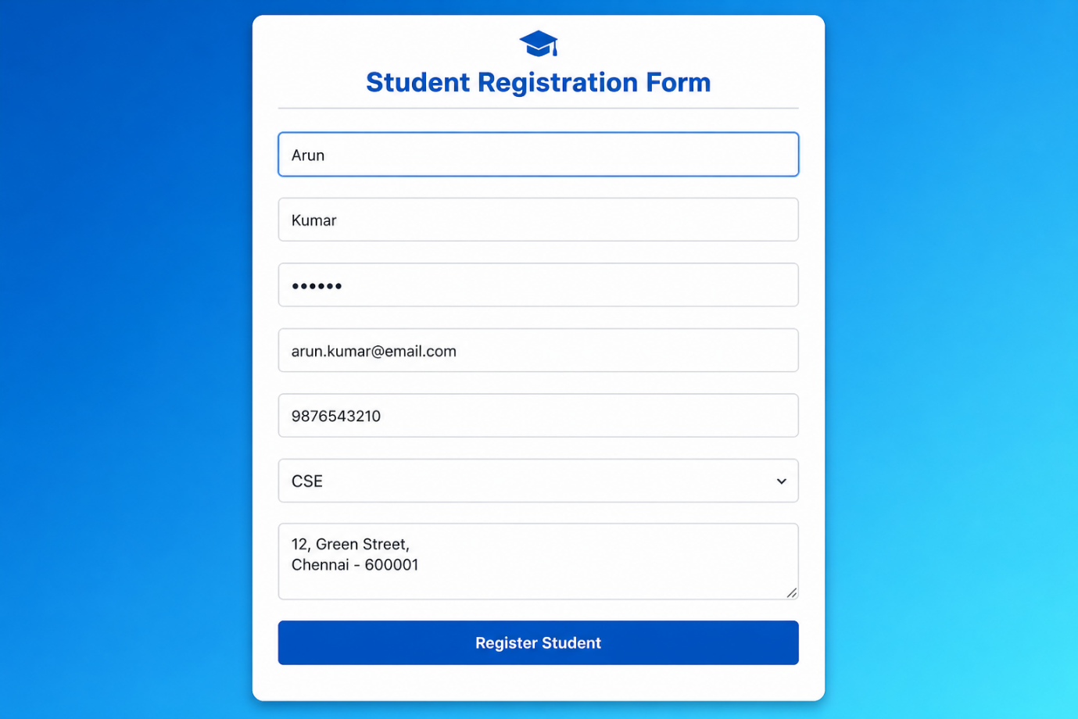

RESULT:
HTML page with Form is created and is validated using Javascript.

